South Dakota Rural Electric Association, Inc.

222 West Pleasant Drive
P.O. Box 1138
Pierre, South Dakota 57501-1138
Phone: 605-224-8823
www.sdrea.coop

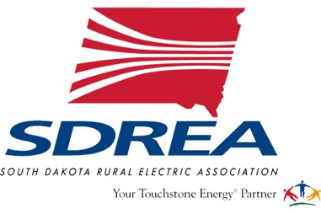

For Immediate Release

Contact: Billy Gibson, Director of Communications, SDREA
billy.gibson@sdrea.coop
225.405.4910

PIERRE – Several South Dakota electric cooperatives answered the call for assistance to restore power after a pair of late winter storms dumped up to five feet of snow in western and north central North Dakota last week.

A team of 26 linemen and their equipment were dispatched Monday morning from West River Electric, Grand Electric, Northern Electric, Lacreek Electric, Butte Electric and West Central Electric. The linemen were assigned to help repair the infrastructure of Burke Divide Electric Cooperative, headquartered in Columbus, ND.

The co-op reported that more than 1,700 poles and roughly 80 miles of power lines were damaged in the blizzard conditions. As of Monday afternoon, more than 800 BDEC members were still without power, and officials estimated that full restoration would likely take several weeks.

Supply shortages, logistical challenges and thick mud created by rain and melting snow could impact the timeline of the recovery effort.

Mark Patterson, manager of loss control services at the South Dakota Rural Electric Association (SDREA), is assisting in coordinating the state’s emergency response as the system honors its mutual aid agreement with cooperatives in North Dakota and throughout the region.

“We’re always on standby to help a fellow cooperative in need. It’s one of the things that sets cooperatives apart,” Patterson said. “This has been an unusual weather event, but we’re always prepared to respond. We never let our guard down because you never know what Mother Nature has in store. It’s a privilege for us to be in a position to help the members of Burke Divide rebuild their system after this destructive blow to their power infrastructure and their community.”

Overall, the storms impacted 14 electric cooperatives in the area and downed more than 4,000 poles and hundreds of miles of distribution and high-voltage transmission lines, as well as utility substations where snow drifts reached eight feet.

The South Dakota linemen will join more than 100 fellow co-op linemen in North Dakota, along with independent contractors, equipment suppliers and other emergency responders.

Photo cutline: Four linemen from Northern Electric (Bath, SD) joined 22 other electric cooperative linemen from South Dakota to assist Burke Divide Electric Cooperative (Columbus, ND) after two snow storms swept through the region last week. Shown left to right are Collin Gades, Riley Whitley, Ben Peterson and Brian Hansen.

