Chief Executive Officer
Montana Electric Cooperatives’ Association

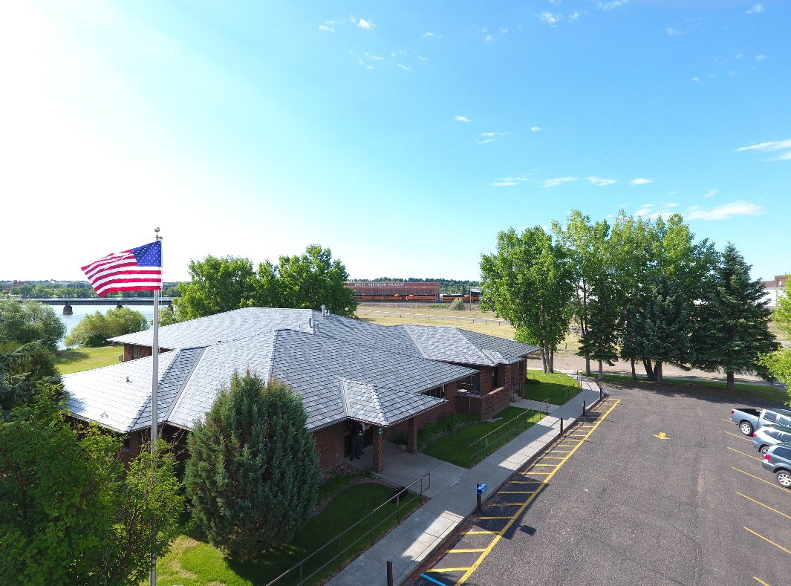

The Board of Directors of Montana Electric Cooperatives’ Association (MECA) headquartered in Great Falls, MT seeks a member focused leader with proven strategic leadership and consensus building expertise, outstanding interpersonal communication skills and strong desire to positively influence and motivate others, to serve as our next CEO. Industry leadership and commitment to cooperative values will set you apart from other candidates. The MECA Board has retained NRECA Executive Search to facilitate the CEO search process.

About MECA
The Montana Electric Cooperatives’ Association (MECA) is a nonprofit, member-driven organization that represents and advocates for 25 distribution cooperatives and three Montana-based generation and transmission cooperatives. MECA operates with a mission to be the unrivaled resource for Montana’s electric cooperatives, focusing on government advocacy, communications and safety and education training.

MECA plays an active role in state and federal legislative processes, advocating for the interests of its member electric cooperatives to ensure rural communities have a strong voice in energy policy. Beyond its advocacy efforts, MECA prioritizes safety and loss control training for its members and serves as the publisher of Rural Montana magazine—the state’s largest-circulation publication, reaching 133,000 readers each month.

The CEO reports to a 25-member board and is entrusted with leading MECA in a way that supports both its employees and its members.
By prioritizing member service and promoting cooperative values, MECA plays a pivotal role in ensuring that rural Montanans have access to essential electric services, empowering communities and supporting a sustainable energy future.

The Ideal Candidate

Leadership Competencies:
- Ability to Lead Change and Manage Risk: Identify and actively manage change and risk throughout the organization
- Vision and Strategic Orientation: Takes a broad scale, long-term view, that focuses on the future needs of the organization and its members
- Member Focus: Focuses self and the organization on the needs of its members
- Analytical Thinking and Decision Making: Thinks systematically, conceptually, and analytically to determine effective solutions that will enable the statewide to achieve desired goals
- Understanding of Financial Issues: Has a good understanding of the key financial opportunities as well as financial risks and budget process.
- Exceptional communication skills, both formally and informally: Listens, relates and expresses oneself in a manner that is effective while supporting mutual understanding. Solid presentation skills is a plus.
- Ability to motivate and positively influence others: Persuades and motivates others towards an outcome consistent with the organization’s mission, vision, and values
- Relationship and teambuilding experience: Creates and fosters constructive working relationships and cohesive teams
- Integrity and Courage: Makes decisions and acts consistently with values, professional standards, and the broader interests of the organization
Experience and Expertise:
- Bachelor’s Degree or the equivalent of work experience and expertise is preferred
- An MBA or other advanced degree is helpful
- Knowledge of the electric industry is a plus
- NRECA Management Internship Program (MIP) graduate or other advanced Leadership Development program is preferred
- Proficiency in Accounting & Finance, Political Science, Government Relations, Training and Development, Business and/or Multi-Stakeholder Organizations is preferred
- Regional power supply and legislative understanding will set you apart
- An understanding and appreciation of cooperative values will distinguish you as a candidate.

Our Location
MECA’s office is located right on the bank of the Missouri River in Great Falls, with beautiful views right outside their windows. Nestled in the heart of Montana, Great Falls is a city that blends natural beauty, vibrant culture, and small-town charm, making it a fantastic place to call home. With its scenic landscapes, rich history, and tight-knit community, Great Falls offers something for everyone. As a regional economic center, Great Falls has a diverse economy supported by healthcare, agriculture, and a growing small business community.

Located along Interstate 15 and close to Glacier National Park, Great Falls is an excellent home base for exploring Montana and beyond. Its central location offers convenience while retaining the charm of a slower-paced lifestyle.

The Board will require that the new CEO live within the greater Great Falls area within a reasonable commuting distance to the MECA office.

Benefits
MECA offers to its employees, excellent pay and benefits including paid vacation leave, sick leave, pension plan, 401k match and health, dental and vision insurance.

Montana Electric Cooperatives’ Association is an EEO/Affirmative Action employer. Race, color, religion, sex, age, national origin, disability, military, veteran status, gender identity, sexual orientation, genetic information or any other applicable status protected by Federal, State or Local law are not taken into account in any employment decision. Learn more about MECA at www.mtco-ops.com

How to apply:

If interested, please apply at https://nreca.applytojob.com/apply/2hAKGOpm5t/Montana-Electric-Cooperatives-Association-CEO with the following: 1) Cover letter, 2) resume and 3) contact information for 3 professional references. Applications must be received by March 7, 2025.

If you have any questions, please contact Leigh Taylor, NRECA Executive Search, at leigh.taylor@nreca.coop. All replies are confidential.




25 Organizational Members
ti
9
employees
Members serve 400,000+
Montanans

